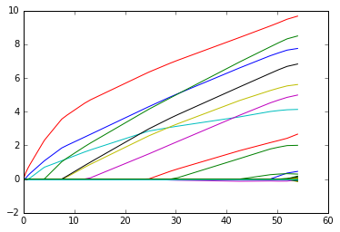  
Stagewise Regression at epsilon = 10-4

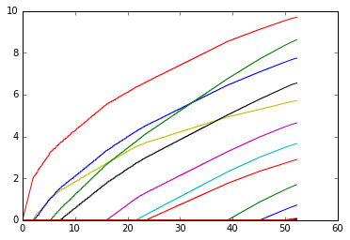  
Lasso Regression (n=50, p=200)

While Stagewise regression gives a non-continuous, stepped graph for values of epsilon of 10-3 and above, comparing Lasso Regression’s solution path to Stagewise Regression’s solution path, we can see that for an epsilon value of 10-4, stagewise regression gives the same result as lasso regression with n =50 and p = 200. Stagewise regression gives smoother paths than lasso, and takes longer to overfit data, as compared to lasso.

All the following plots were taken with these initial values:

n=100  
p=500  
s=10  
numIter=3000

Epsilon was varied exponentially from 0.000001 to 0.1

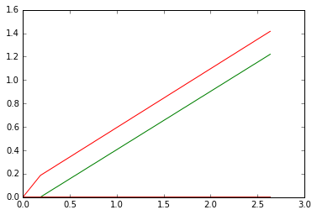  
Epsilon = 10-6

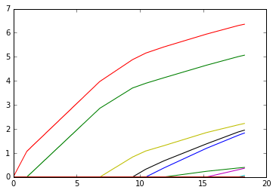  
epsilon = 10-5

  
Epsilon = 10-4

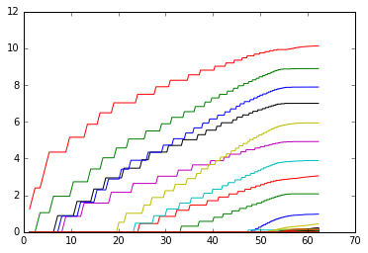  
Epsilon = 10-3

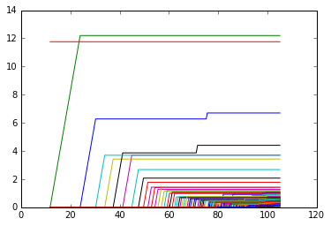  
Epsilon = 10-2

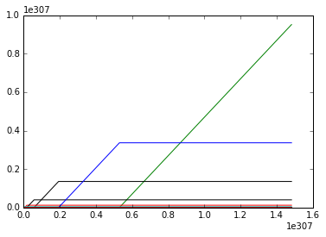  
Epsilon = 10-1

**Code to reproduce plot in python:**

**Input code:**

n = 100  
p = 500  
s = 10  
X = np.random.standard_normal((n,p))  
beta_true = np.zeros(p)  
beta_true[0:s] = range(1, s+1)  
Y = np.add(np.dot(X,beta_true),np.random.standard_normal(n,))  
swRegression(X,Y)

**Plot code:**

u = np.transpose(np.dot(np.ones((1,p)),abs(beta_all)))  
v = np.transpose(beta_all)  
plt.figure()  
plt.plot(u, v, label='Stagewise Regression')

**Code to reproduce plot in R:**

**Input code:**

n = 100  
p = 500  
s = 10  
X = matrix(rnorm(n*p),nrow = n)  
beta_true = matrix(rep(0,p), nrow = p)  
beta_true[1:s] = 1:s  
Y=X%*%beta_true + rnorm(n)  
swRegression(X,Y)

**Plot code:**

matplot(t(matrix(rep(1, p), nrow = 1)%*%abs(beta_all)), t(beta_all), type = 'l')